**1050 Programming Logic**

Lab 3 (20 points total)

Name: ___________________________

*Add responses to questions as comments in your code.*

1. Compare and contrast the if single-selection statement and the while repetition statement. How are these two statements similar? How are they different? (2 Points).

**The If statement will run once unless planted in a loop, Its similar to the while statement because both will check if a statement is true and if it is true it will execute all commands within its body. The while statement is different because it will run multiple times until the statement is false.**

**For example take this bit of code:**

**Int i = 0;**

**//this will run one time, the result will be “1 Hello”**

**If (i <= 10) { i++; Console.WriteLine(“{0} Hello”,i);**

**//this will run until i = 11 because then it is no longer <= 10. The output should be 10 lines of “# Hello”**

**While (i <= 10) {i++; Console.WriteLine(“{0} Hello”,i);**

1. Declare two int variables: 1) speedLimit and 2) speed. Assign values speedLimit=35 and speed=42. Write an if statement that displays “SLOW NOW” if speed is greater than speedLimit. (2 points)

int SpeedLimit = 35;

int Speed = 42;

if (Speed > SpeedLimit)

{

Console.WriteLine("SLOW NOW");

}

1. if-else statement - Write a program that declares and assigns a value to a Boolean variable called isTrue. Use a condition to output “It is True!” or “It is False!” based on the assigned value. Paste your code and screenshots of your program running with both true and false values (3 points).

Example: bool isTrue = true;

bool isTrue = false;

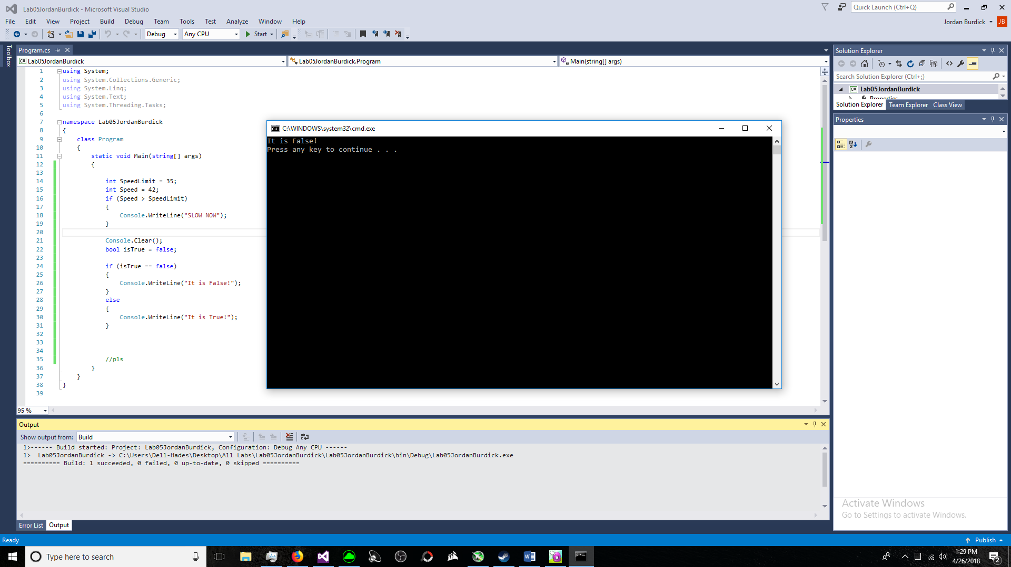

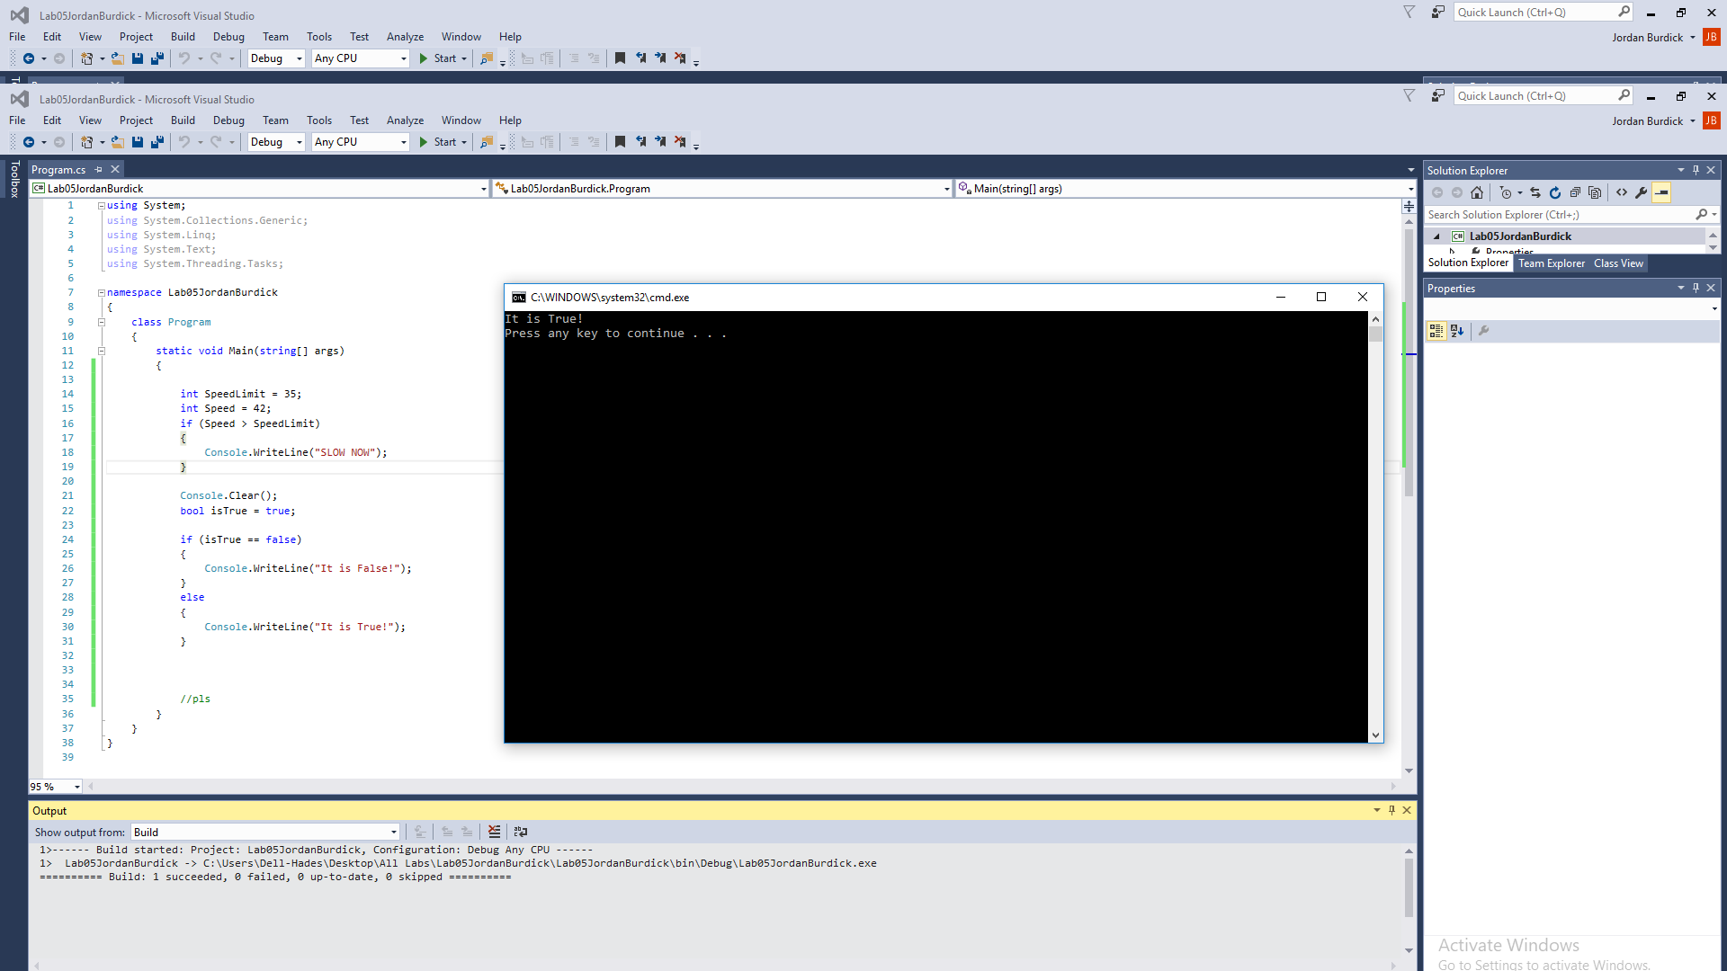

1. if statement - Write a program that converts a Fahrenheit temperature to Celsius. The user should be able to input the temperature at the Command prompt and it should output the temperature. In addition, you should output “It is cold” if the Fahrenheit value is less that 40 or it should output “It is hot” if the temperature is over 90 (4 points). ***Code to read a value: double fahrenheit = Convert.ToDouble(Console.ReadLine()); Code to convert: celsius = (fahrenheit - 32d) * 5d / 9d;***
2. **Write a while loop** that outputs values 1-10. Increment by 1 (3 points).
3. **Write a while loop** that outputs values 60 to 20. Decrement by 1 (3 points)
4. **Create a while** that outputs values 10-20 (3 points).